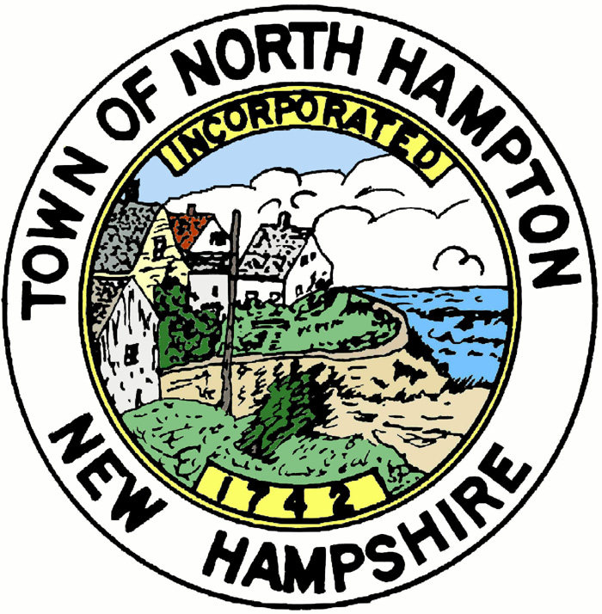
AGENDA
TOWN OF NORTH HAMPTON
Planning Board
Long Range Planning Committee
Thursday, April 14, 2016 at 8:00am
Town Office Conference Room
233 Atlantic Avenue

The Long Range Planning Committee will meet on Thursday, April 14, 2016 at 8:00am in the Town Office conference room to discuss the 2016 Town-wide survey, village concept language, and village concept map.

Posted: April 6, 2016
Town Clerk’s Office
Town Office
Library
www.northhampton-nh.gov
Respectfully submitted,

Dan Derby
Planning Board

